THE HORTICULTURAL CENTRE FOR THE CITY OF PARIS

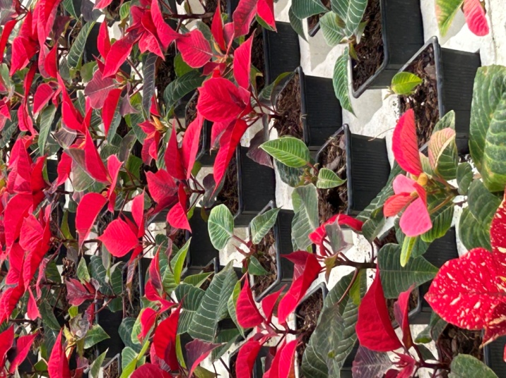

The nursery, located in Rungis, encompasses 40 hectares and is
responsible for the growth and distribution of millions of plants
used in Paris and its surrounding regions.
It is all funded by Paris City Hall.

The Greenhouses

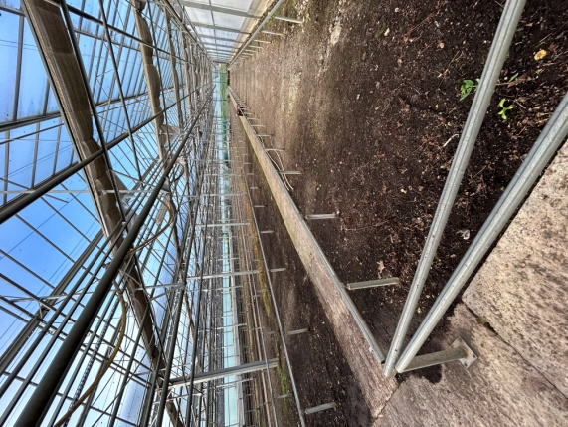
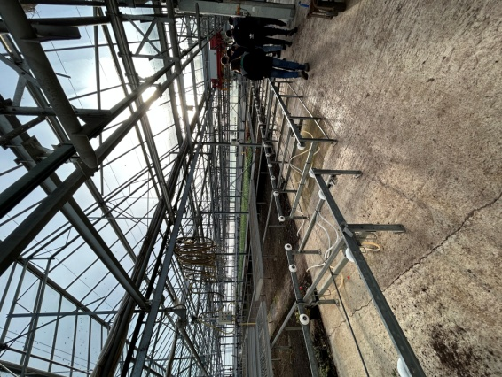
The production area contains a multitude of greenhouses and machinery rooms. The greenhouses are equipped with automated systems to help workers in repetitive and difficult tasks. There are also automatic ventilation and heating systems to regulate the interior temperatures as well as watering and irrigation systems. The plants are moved on heavy pallets using conveyors or a system called a transmaster. This system works as a crane to pick up the pallets and convey them along two axes within a greenhouse.

The Machinery

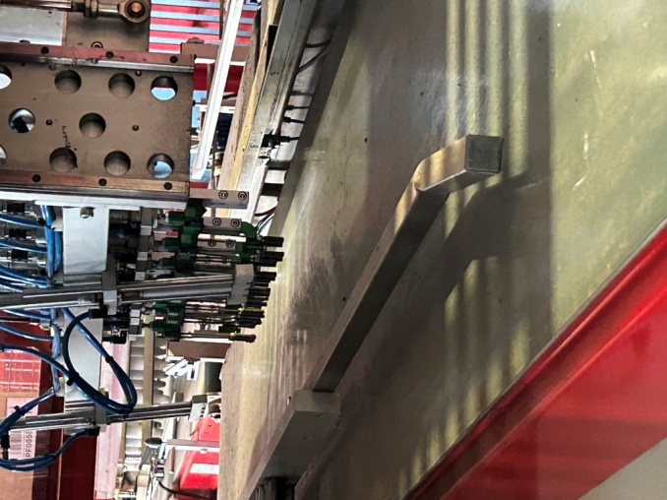
The majority of the machinery is located in a big hangar. In this hangar one can find a line-up of multiple mechanisms joined together by conveyor belts. Soil is fed into one end of the line, seeds are then planted, and the final machine layers the top of the soil with vermiculite. The latter is a soil supplement that insures the proper circulation of water throughout the soil. Once the seeds are planted, they are sorted manually into large trays and put into one of the two germination rooms. The seeds can take anywhere from a couple of days to a couple of months to germinate. In these rooms, the conditions such as temperature and humidity, are closely monitored. At the end of the germination process the plants are potted and housed in their respective greenhouses.

Tree planting

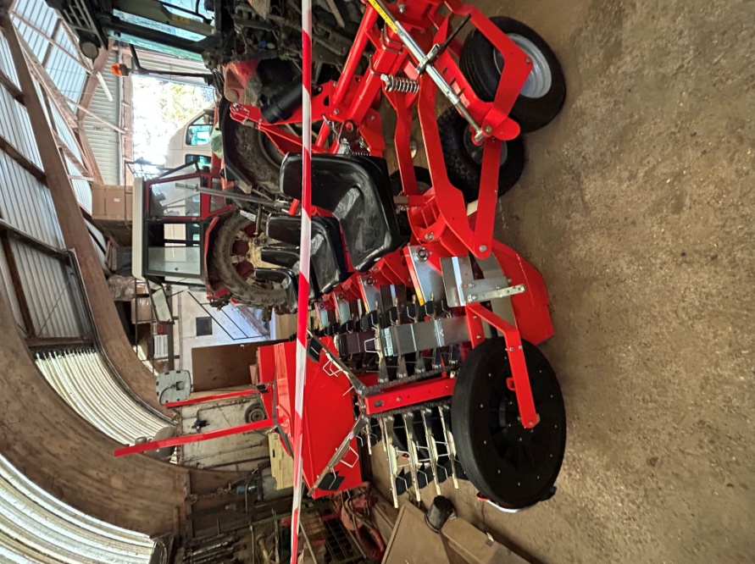

There are also exterior plants and trees, which a majority of the space is dedicated to. For these, the workers employ tractors and forklifts in order to accelerate the planting process. A tractor is used with a rear attachment that enables four people to sit while simultaneously dropping plants into furrowed soil which is then covered up. Also, forklifts are used to pick up big batches of pots for easy transportation.

The Potting Machine

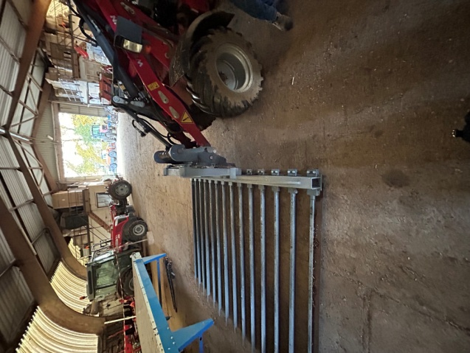
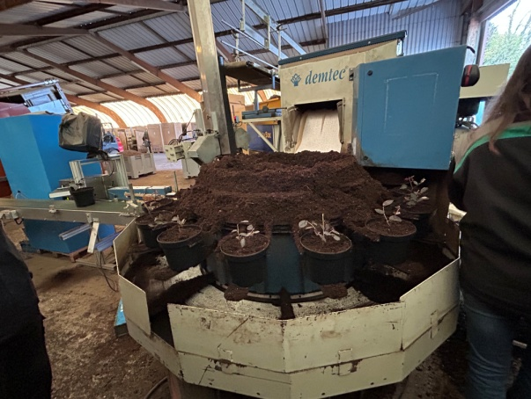
One of the most useful machines is the potting machine, whose function is to fill plant pots with soil. The system is filled with soil, and supplied with plastic pots. The pots are dropped into rings, to hold them, which rotate in a big circle while they are manually filled with plants. They then pass under measured filling of oil. They leave the system on a conveyer belt and are arranged in rows, ready to be picked up by a forklift.

